Design Overview
This implementation of Tic-Tac-Toe follows a modular approach, separating functionalities into logical units using different `.h` and `.c` files. Here's the detailed breakdown of the design:

Main Program (`main.c`)
Acts as the entry point of the program.
1. Loads game statistics from a file (`game.txt`).
2. Initiates a game loop where the user can repeatedly play games.
3. Saves updated statistics back to the file after the games.

Board Management (`board.h` and `board.c`)
Manages the Tic-Tac-Toe board and handles display and state validation.
Functions:
- initialize_board: Initializes the 3x3 board with `'-'`.
- display_board: Renders the current state of the board to the console.
- make_move: Updates the board with the player’s move

Player Interaction (`player.h` and `player.c`)
Handles player moves and validates them.
Functions:
- get_move: Prompts the player for their move and validates the input (e.g., valid row/column, unoccupied space).
- Ensures that players only input valid moves; invalid inputs prompt the player to retry.

Game Logic (`game.h` and `game.c`)
Coordinates the gameplay.
Functions:
- play_game: Handles a single game session.
- Alternates turns between Player 1 and Player 2.
- Calls board and player functions to update and render the state.
- Tracks turn counts to calculate statistics like maximum, minimum, and total turns.
- Determines game outcomes (win or tie) and updates the relevant statistics.

Statistics Management (`statistics.h` and `statistics.c`)
- Maintains and persists game statistics.
Statistics Tracked:
- Player 1 Wins, Player 2 Wins, Ties.
- Total Turns, Maximum Turns, Minimum Turns.
Functions:
- load_statistics: Reads statistics from `game.txt`. If the file doesn't exist, initializes default values.
- save_statistics: Writes the updated statistics to `game.txt`.
Game Flow
- Load game statistics from game.txt.
- Initialize a new game board.
- Alternate turns between Player 1 (x) and Player 2 (o).
- Validate moves and update the board.
- Check for a winner or a tie after each turn.
- Display updated statistics at the end of the game.
- Prompt players to replay or exit.
- Save updated statistics to game.txt.

Test Cases
1. Board Initialization
- Input: Start the game.
- Expected Output: Empty board with rows labeled A to C and columns 1 to 3.
- Test: Verify that the board displays correctly.
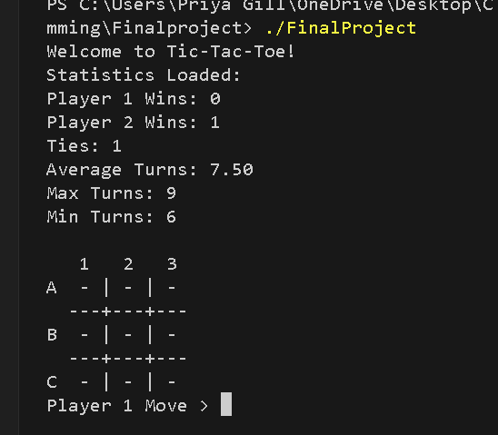
2. Player Move Validation
- Input: Enter a valid move (e.g., A-1).
- Expected Output: Board updates with x or o in the correct position.
- Input: Enter an invalid move.
- Expected Output: Error message and re-prompt.
- Input: Enter a move on an already occupied square.
- Expected Output: Error message and re-prompt.
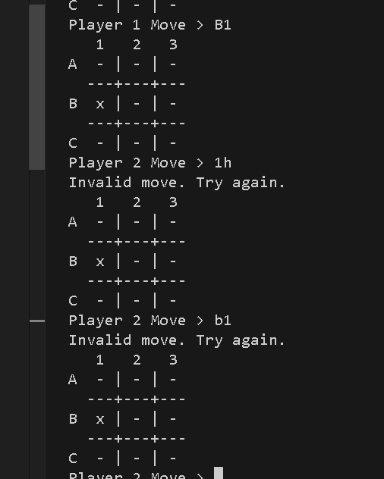
3. Winning Condition
- Input: Player places three consecutive marks horizontally, vertically, or diagonally.
- Expected Output: Announce the winning player.
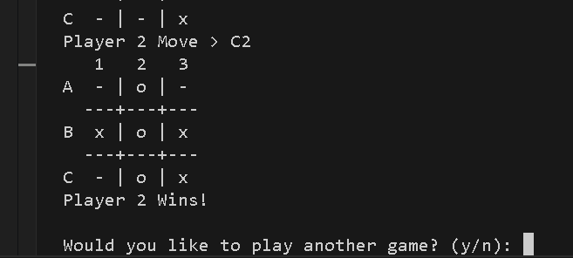
4. Tie Condition
- Input: Fill the board with no winning combinations.
- Expected Output: Announce a tie.
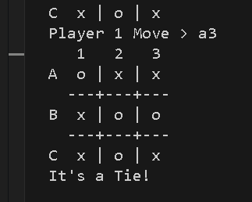
5. Statistics Management
- Input: Play multiple games and end the program.
- Expected Output: Updated game.txt with correct statistics.
- Input: Restart the program.
- Expected Output: Statistics persist from the previous session.
